

Golden Gate OEM 13c Agent Installation
OEM 13C Version 13.3.0.0.0

Project



DISCLAIMER

This document is strictly private, confidential and personal to its recipients and should not be copied, distributed or reproduced in whole or in part, nor passed to any third party.

Version history
Date | Version | Description | Author
2017-10-11 | 1.0 | Initial Draft | Sharang Dwivedi
 |  | Reviewed
 |  | Approver

Contents
Version history 3
1. Introduction 4
2. Steps to be performed 5
3. Deploy Golden gate plugin on management server 5
4. Deploy Golden gate plugin on target server 9
5. Install JAGENT software on target server 12

Introduction

We can monitor GoldenGate processes like manager, extract and replicat and also the lag from OEM 13c cloud control. This document describes the installation and configuration process of OEM 13c GoldenGate Plug In.

Steps to be performed
- GoldenGate plugin to be deployed on the management server.
- GoldenGate plugin to be deployed on the management agent server(where GoldenGate is running)
- JAGENT software to be installed on server( where GoldenGate is running)

Deploy Golden gate plugin on management server

Setup -> EXTENSIBILITY -> PLUG IN -> DEPLOY ON – > MANAGEMENT SERVER
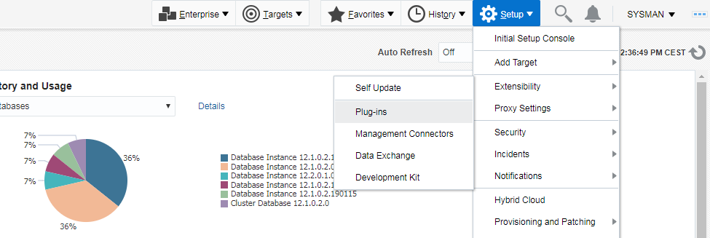

Select Oracle GoldenGate
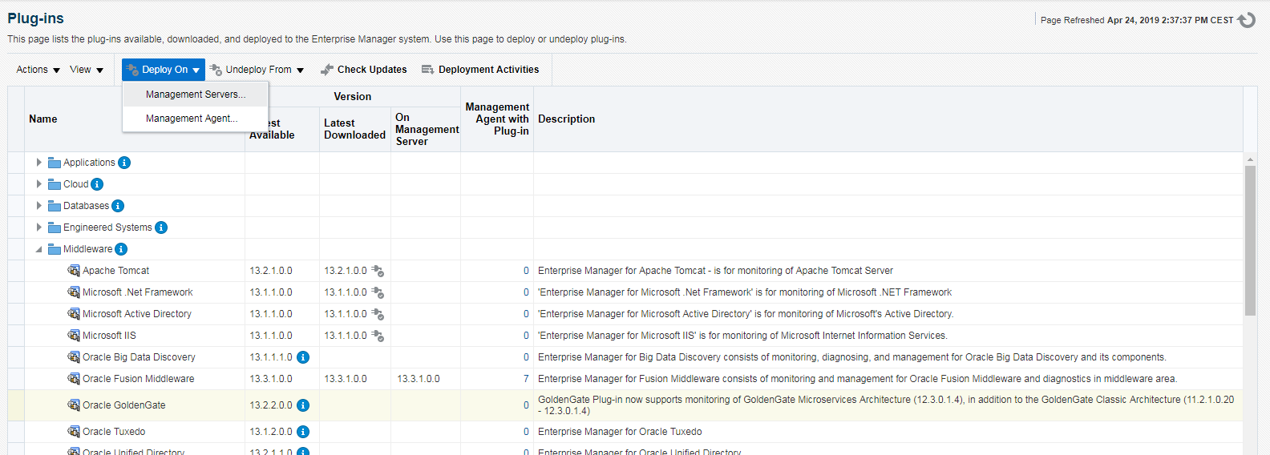

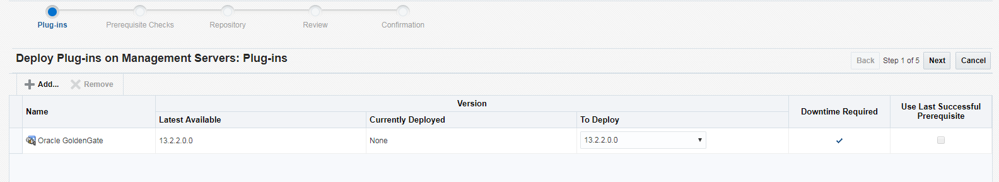

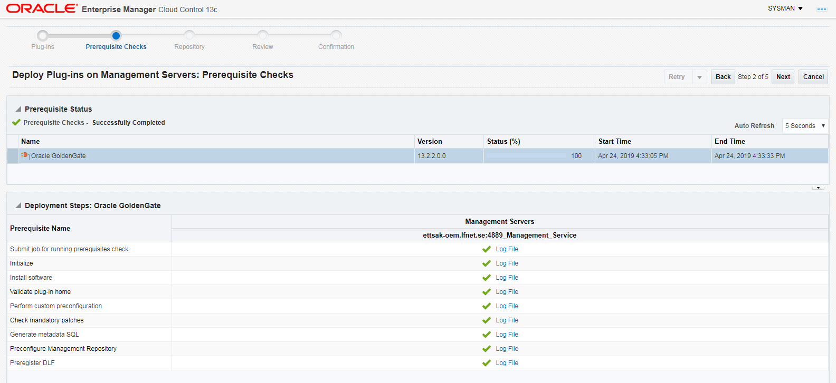

Provide sys password for OEMDB
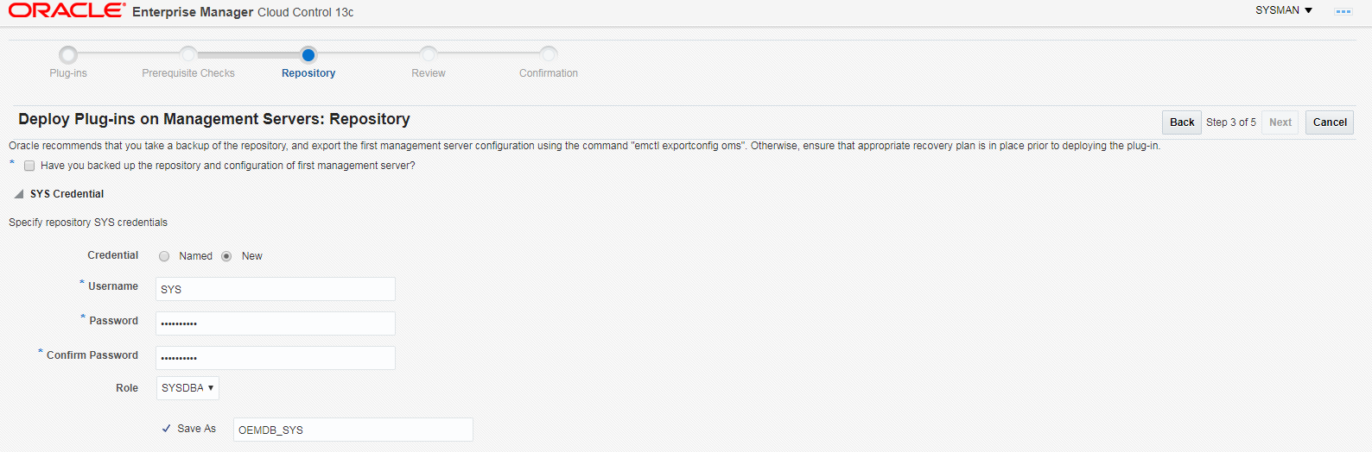

Take the backup of OEMDB and export the management server configuration using the command "emctl exportconfig oms".
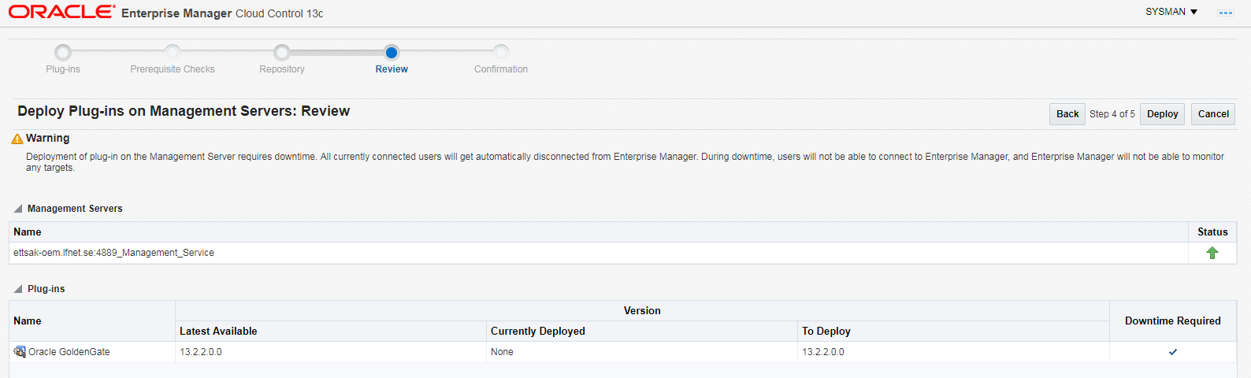

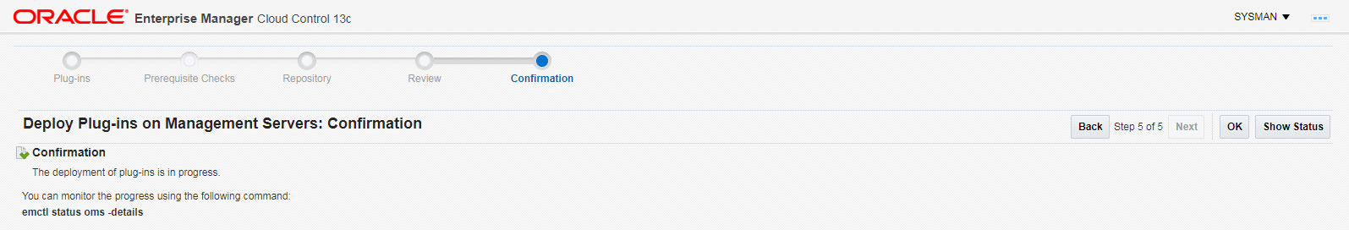

Deploy Golden gate plugin on target server

Setup -> EXTENSIBILITY -> PLUG IN -> DEPLOY ON – > MANAGEMENT AGENT
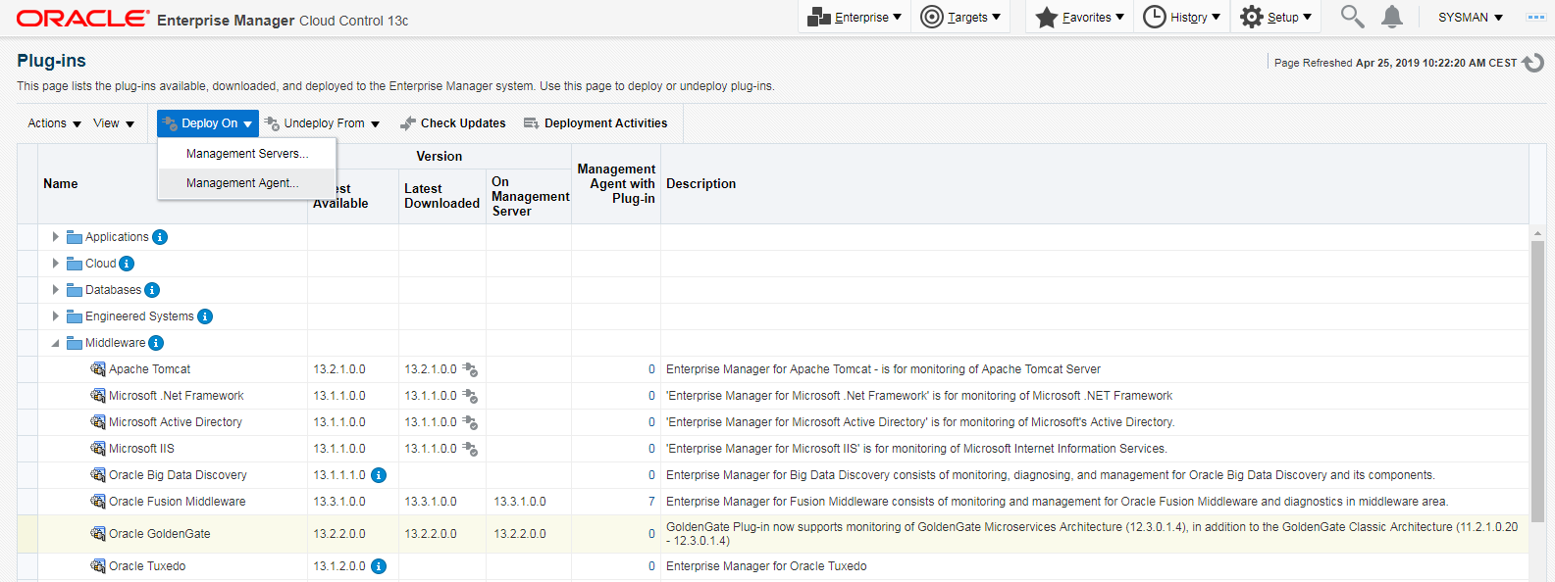
Select Oracle GoldenGate
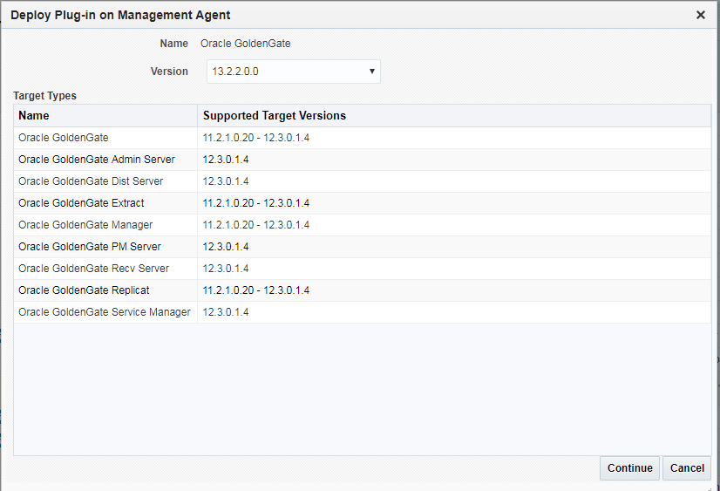

Select the target host
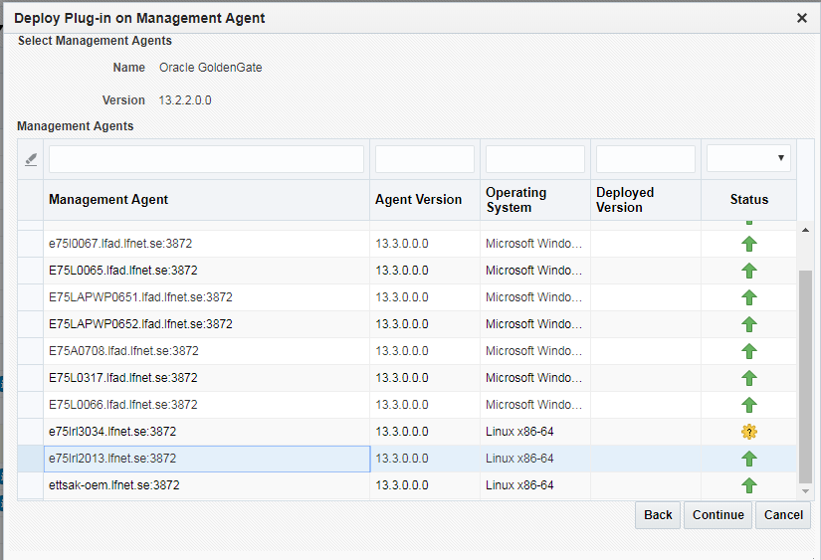
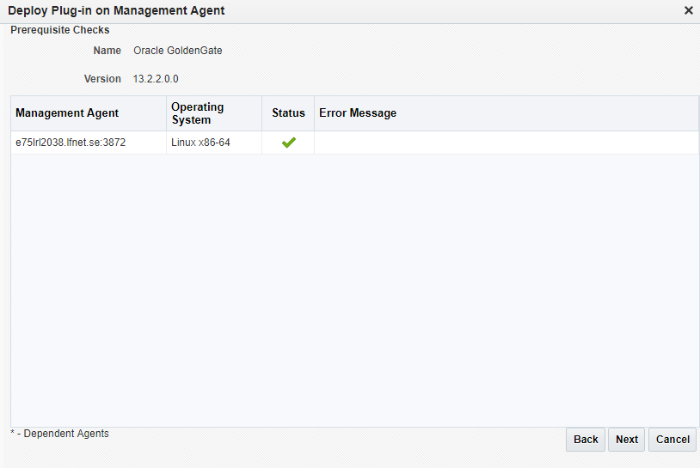
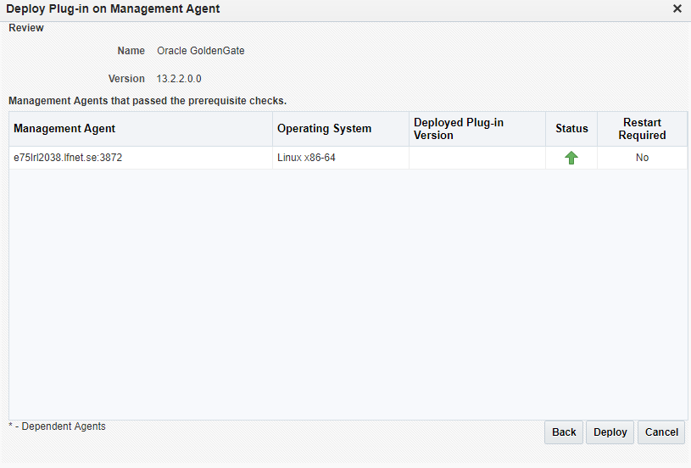
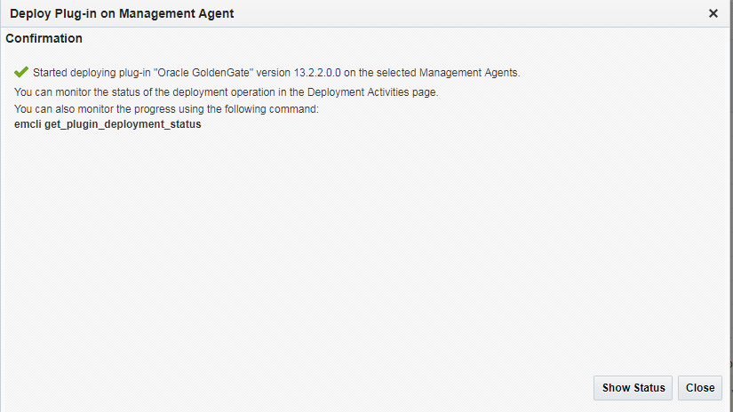
Monitor the Plug In installation status
Setup -> EXTENSIBILITY -> PLUG IN -> DEPLOY ON – > Deployment Activities
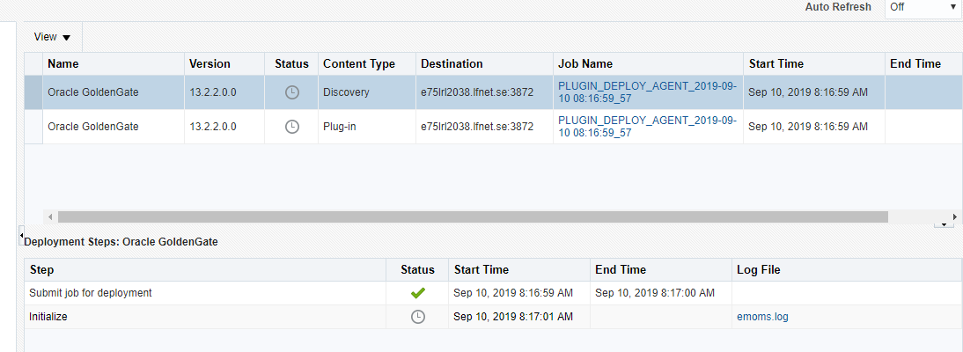

Install JAGENT software on target server

- Download the software from Oracle(if not available)
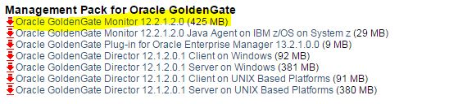
NOTE: JDK version should be > = 1. 8
[oracle@e75lrl2013.lfnet.se-] /home/oracle > java -version
openjdk version "1.8.0_191"
OpenJDK Runtime Environment (build 1.8.0_191-b12)
OpenJDK Server VM (build 25.191-b12, mixed mode)
- Copy software to target database and unzip.
[grid@e75lrl2013 OEM13c_GGAGENT_MONITOR_SOFTWARE]$ pwd
/g01/app/OEM13c_GGAGENT_MONITOR_SOFTWARE
[grid@e75lrl2013 OEM13c_GGAGENT_MONITOR_SOFTWARE]$ ll
total 435372
-rw-r--r--. 1 grid oinstall 445820174 Apr 25 11:31 fmw_12.2.1.2.0_ogg_Disk1_1of1.zip
[grid@e75lrl2013 OEM13c_GGAGENT_MONITOR_SOFTWARE]$
[grid@e75lrl2013 OEM13c_GGAGENT_MONITOR_SOFTWARE]$
[grid@e75lrl2013 OEM13c_GGAGENT_MONITOR_SOFTWARE]$ unzip fmw_12.2.1.2.0_ogg_Disk1_1of1.zip
Archive: fmw_12.2.1.2.0_ogg_Disk1_1of1.zip
inflating: fmw_12.2.1.2.0_ogg.jar
inflating: fmw_12212_readme.htm
[grid@e75lrl2013 OEM13c_GGAGENT_MONITOR_SOFTWARE]$ ll
total 870952
-rw-r--r--. 1 grid oinstall 445820174 Apr 25 11:31 fmw_12.2.1.2.0_ogg_Disk1_1of1.zip
-r-xr-xr-x. 1 grid oinstall 446021430 Oct 12 2016 fmw_12.2.1.2.0_ogg.jar
-rw-r--r--. 1 grid oinstall 8986 Oct 11 2016 fmw_12212_readme.htm

- Enable X11 and start the installation

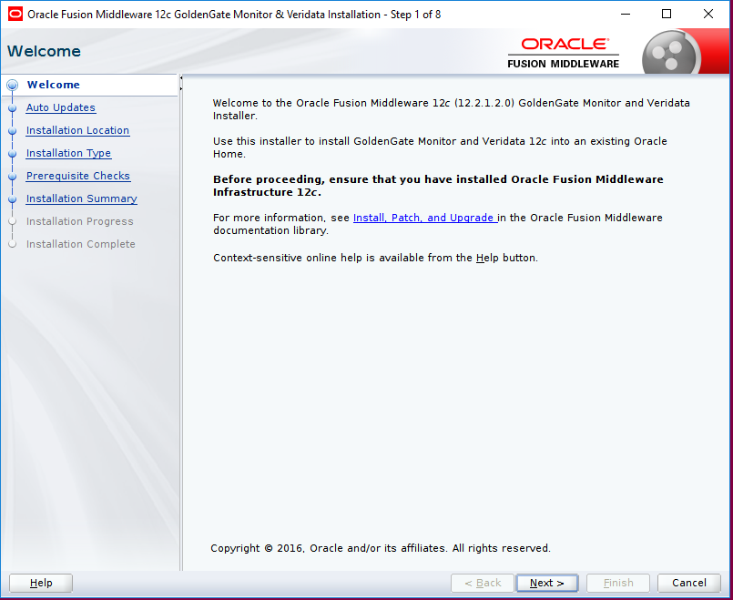
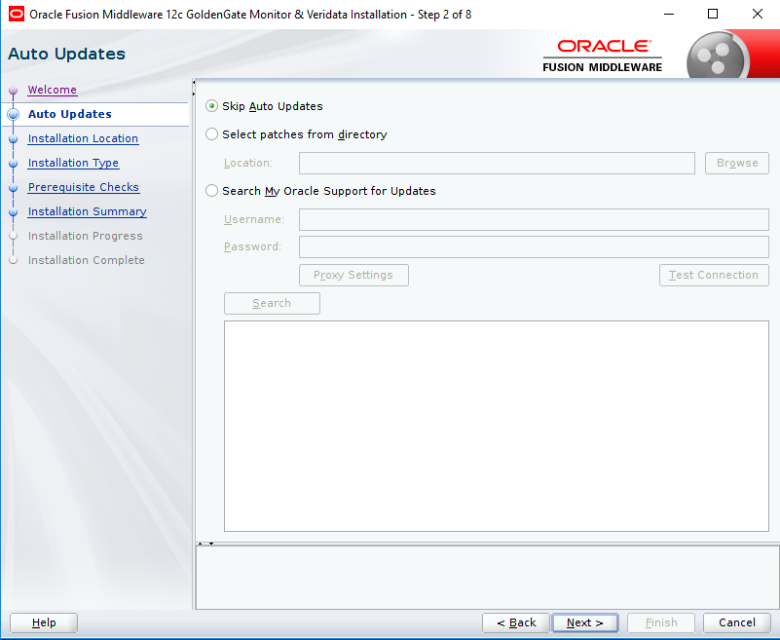

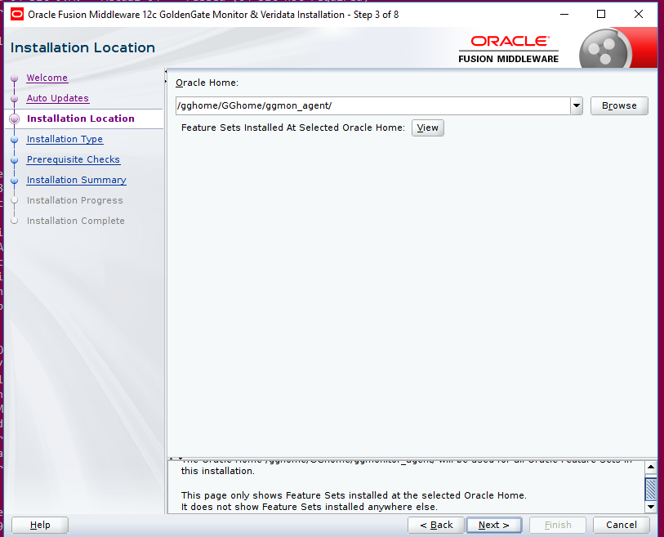
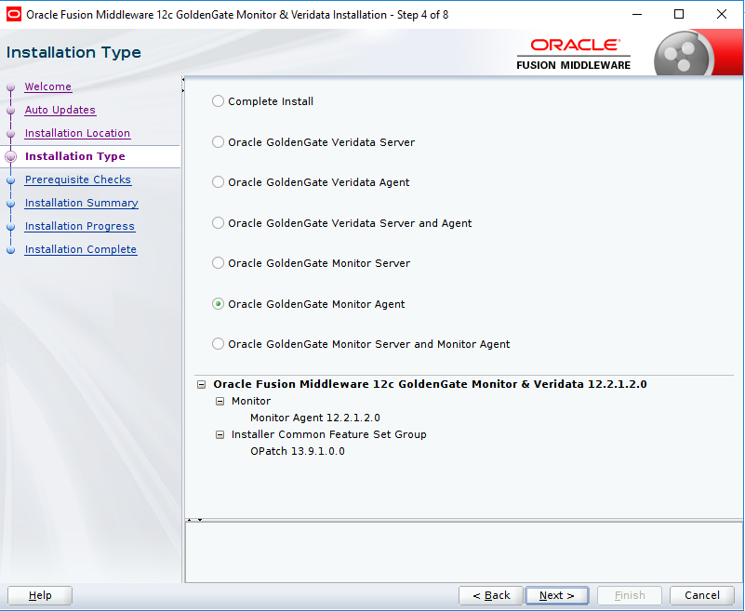
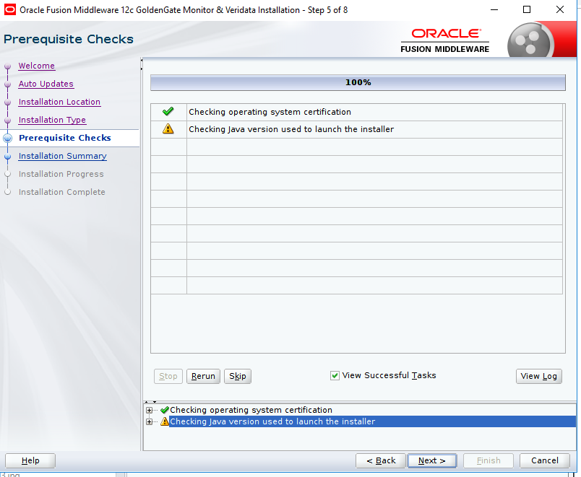
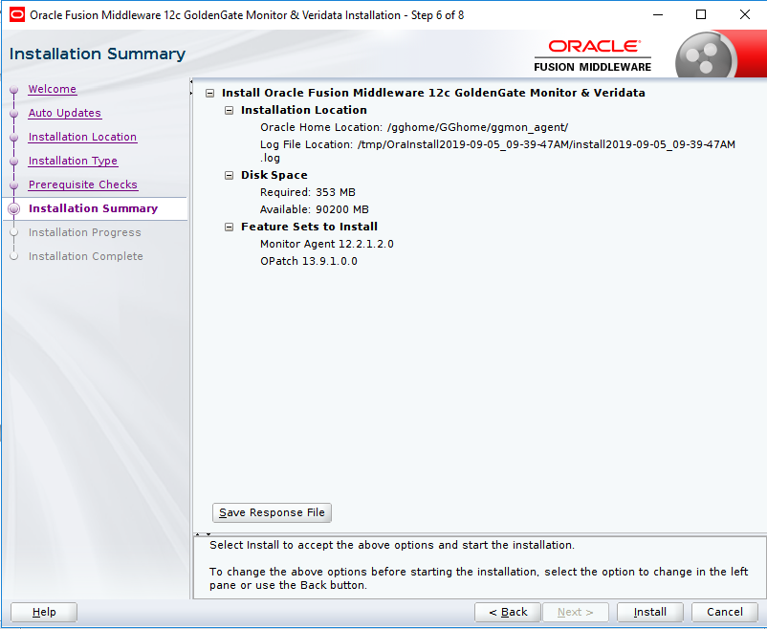
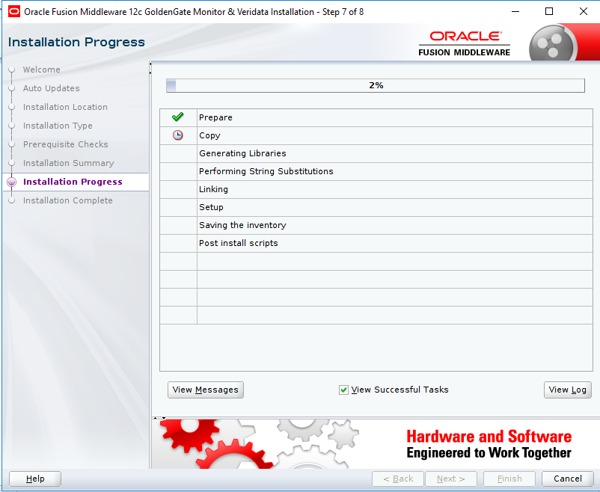
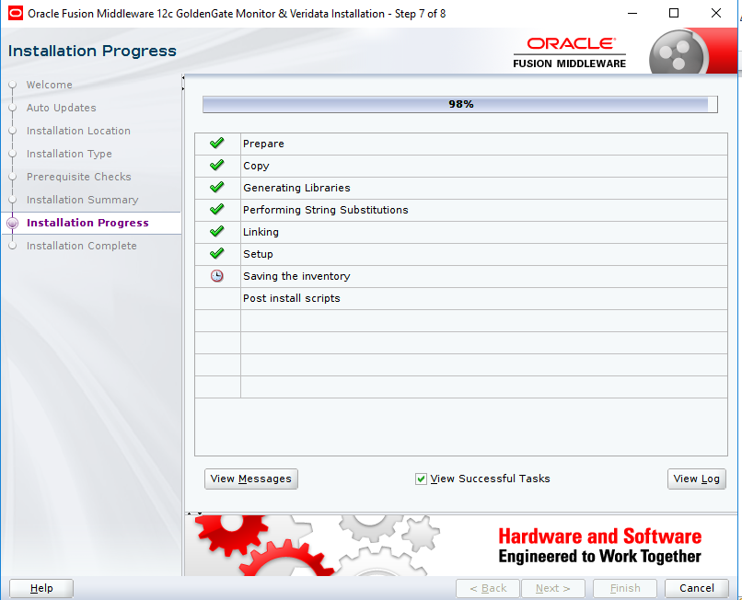
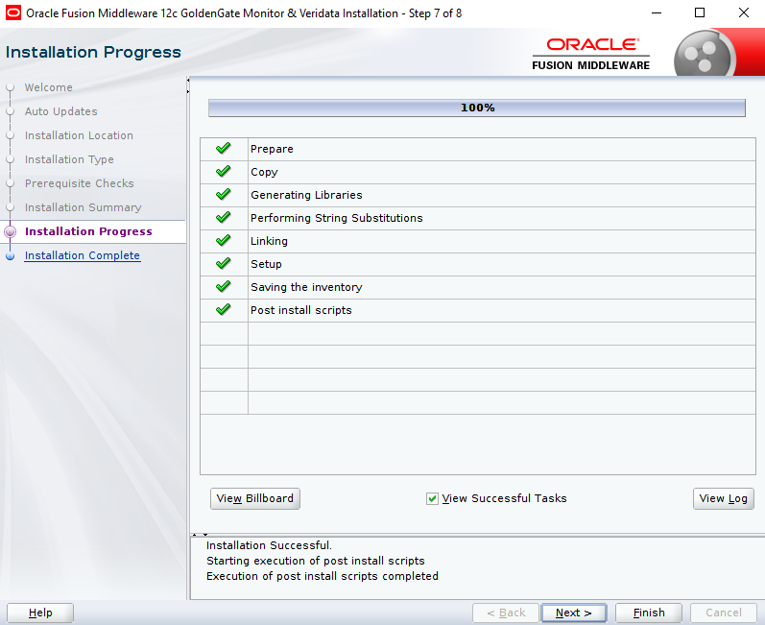

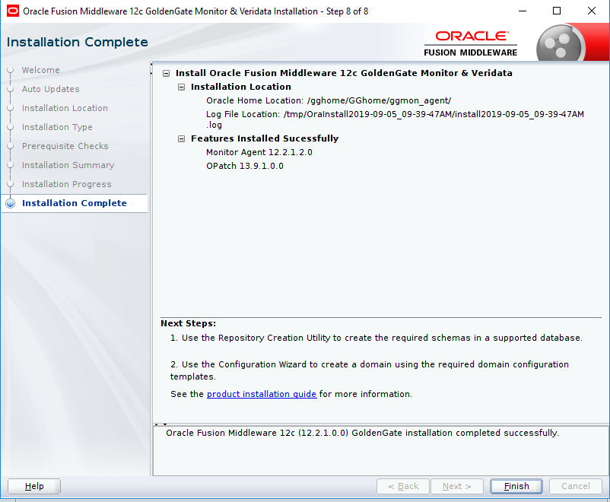

Create an agent instance:

Create an wallet:
Configuration File update
1. Edit configuration file /gghome/GGhome/ggmon_agent/oggagent_13c/cfg/Config.properties
2. Add (or check) the following
jagent.host=e75lrl2038.lfnet.se
jagent.username=jagentuser
agent.type.enabled=OEM

Update GLOBALS file.
[grid@e75lrl2038 oggcore_1]$ pwd
/gghome/GGhome/product/12.2.0/oggcore_1
[grid@e75lrl2038 oggcore_1]$
[grid@e75lrl2038 oggcore_1]$ cat GLOBALS
GGSCHEMA ggadmin
ALLOWOUTPUTDIR /gghome/GGhome/product/12.2.0/oggcore_1/dirdat
checkpointtable ggadmin.gg_checkpoint
ENABLEMONITORING
[grid@e75lrl2038 oggcore_1]$

Restart the goldengate manager and other process and jagent

Discover golden Gate processes on OEM cloud control.
SETUP -> ADD TARGET -> CONFIGURE AUTO DISCOVERY
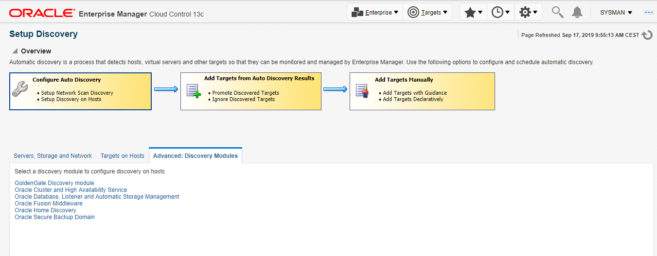ADVANCED: DISCOVERY MODULE -> GOLDENGATE DISCOVERY
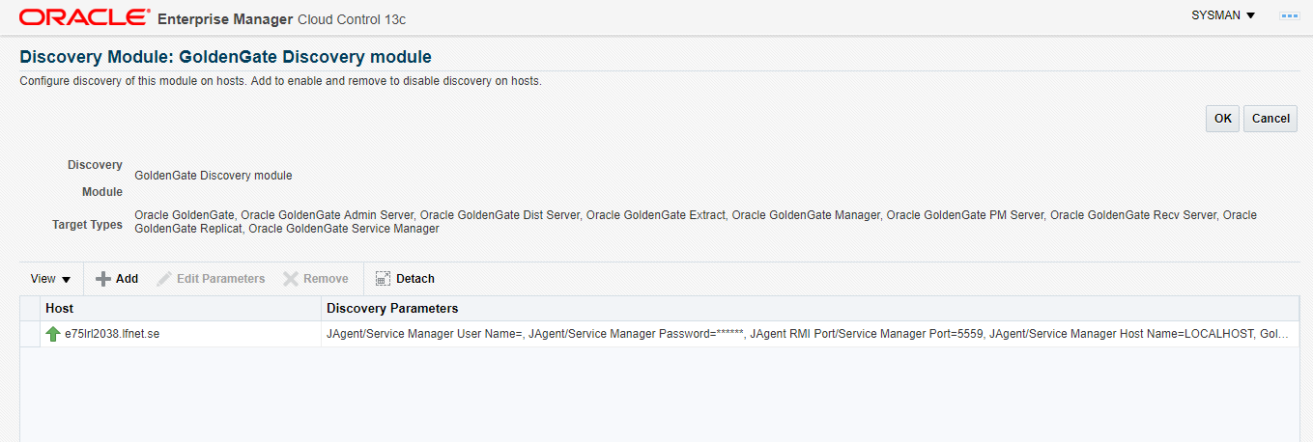

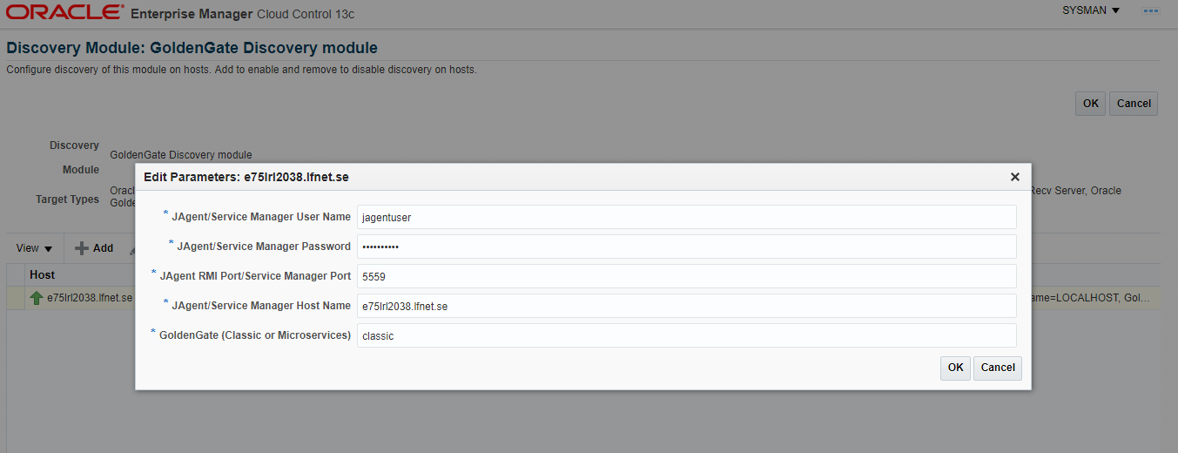
TARGET ON HOSTS – > DISCOVER NOW
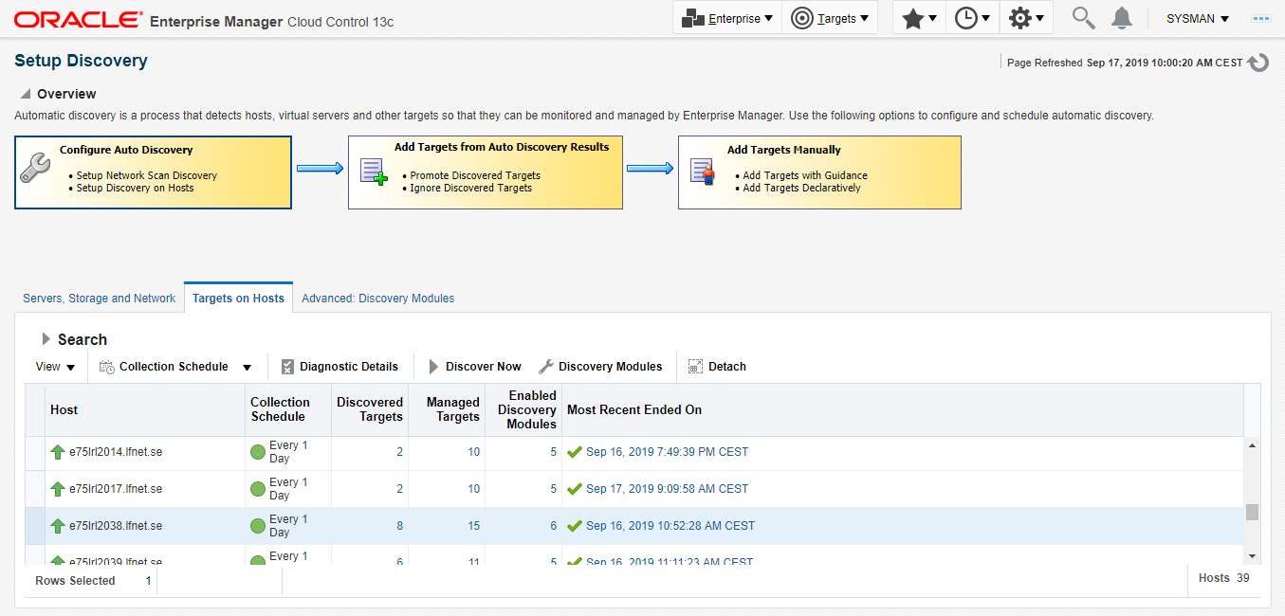
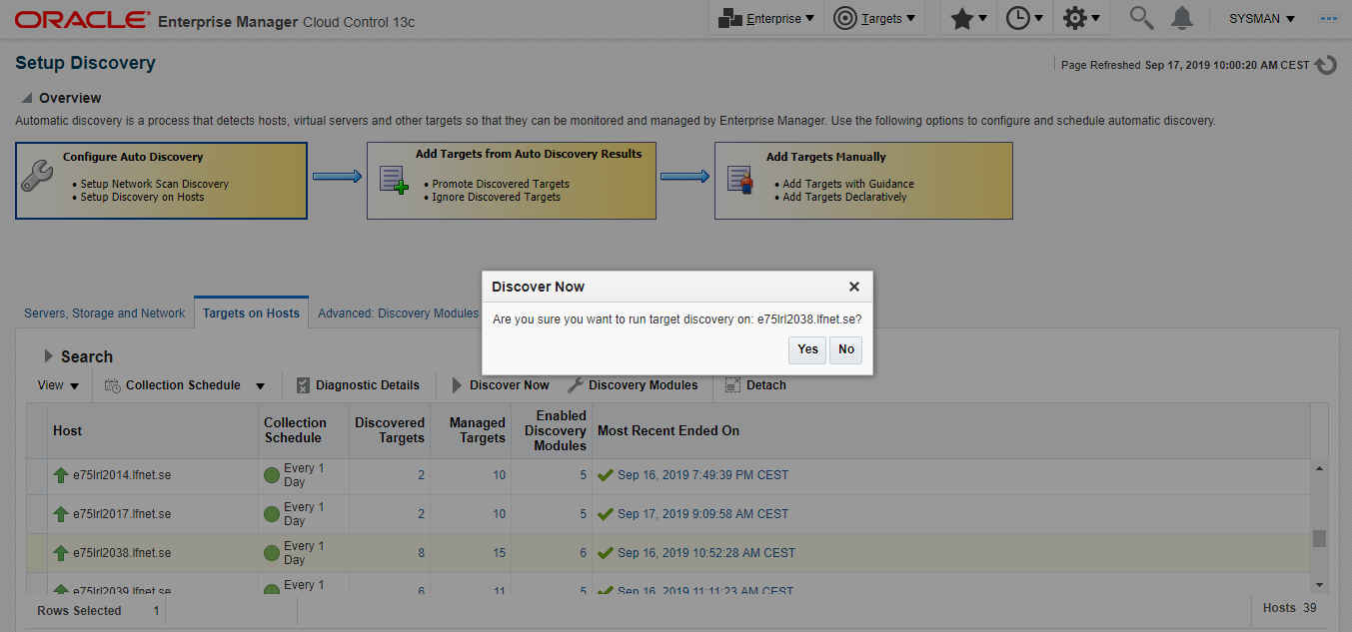

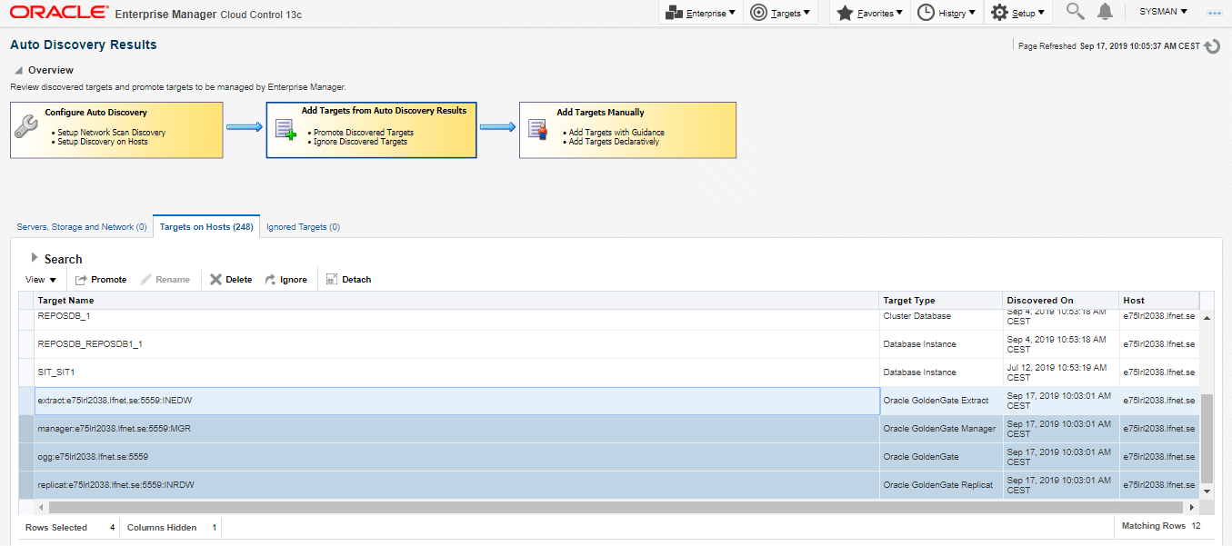
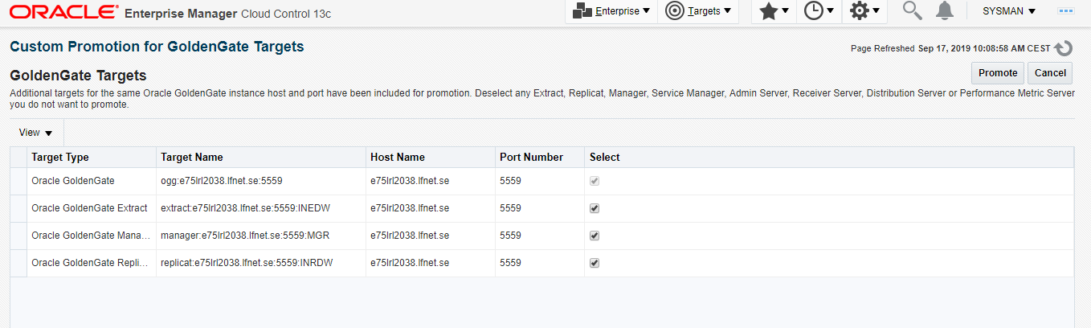
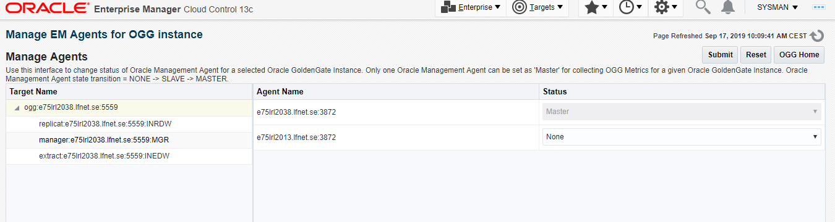
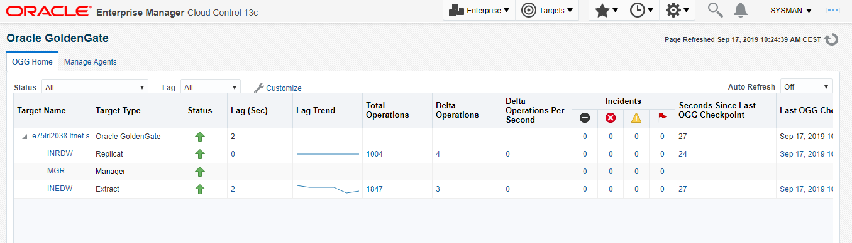

END OF DOCUMENT

